The Director,
Department of Skill Development,
Jammu and Kashmir.
No: KGP/Estt/2026/ Dated:01-08-2026
Subject: Submission of details regarding requirement of Guest Faculty/ Contractual Teachers on Academic Arrangement basis – Regarding.
Sir,
With reference to your office letter/circular No. Poly/28/2025-05/7663511/2086-2109 dated 12-06-2026 regarding engagement of Contractual Teachers/Guest Lecturers on Academic Arrangement basis in Government Polytechnics, the requisite information was duly conveyed to all Heads of Departments / Incharges of this institution for submission of subject-wise and branch-wise details of teaching workload.
Based on the information received from the concerned Heads of Departments / Incharges, it is submitted that there is a total requirement of 15 (Fifteen) Guest Faculties in this institution for the ND26 session. Out of these, 12 (Twelve) faculty members are continuing based on Court directions, and 03 (Three) additional faculty members are required to be engaged for the current academic session.
Further, as per the assessment carried out in the Computer Engineering Department, the total teaching staff presently available is 09 (Nine), comprising 03 Academic Arrangement faculty members, 04 Demonstrators, and 02 Lecturer-I. Out of these, 07 (Seven) faculty members are required for the current academic session.
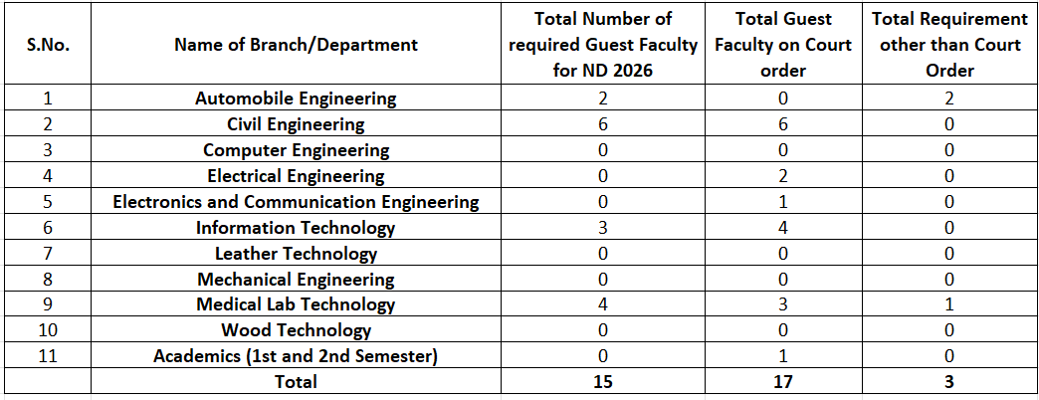
The department-wise information is given below for your kind information.

Yours Faithfully

Principal
Kashmir Government Polytechnic College
Srinagar

